Prithvi Dhirwani
D15C 25
MLDL
Practical 2
Implementation of Multiple Linear Regression, Ridge Regression, and Lasso Regression on a Real-World Dataset

1. Dataset Source
The dataset used for this experiment is a real-world Vehicle CO₂ Emissions Dataset, obtained from Kaggle.
Dataset Link:
https://www.kaggle.com/datasets/brsahan/vehicle-co2-emissions-dataset
This dataset is derived from official vehicle fuel consumption data and is widely used for regression-based prediction tasks.

2. Dataset Overview
The Vehicle CO₂ Emissions dataset includes detailed specifications of various vehicles along with their fuel consumption data. The primary objective is to estimate a vehicle’s CO₂ emissions (g/km) using engine characteristics and fuel usage indicators.
Dataset Properties
- Approximate Records: 7,300 vehicles
- Data Type: Structured numerical dataset
- Application Domain: Automotive and environmental impact analysis
Selected Features
Feature | Explanation
Engine Size (L) | Engine capacity measured in liters
Cylinders | Total number of cylinders in the engine
Fuel Consumption City (L/100 km) | Fuel usage during city driving conditions
Fuel Consumption Hwy (L/100 km) | Fuel usage during highway driving
Fuel Consumption Comb (L/100 km) | Average combined fuel consumption
Target Variable
- CO₂ Emissions (g/km): Quantity of carbon dioxide emitted per kilometer
The dataset contains minimal missing data and is well-suited for regression modeling tasks.

3. Mathematical Formulation of the Models
Multiple Linear Regression
Multiple Linear Regression explains the relationship between one dependent variable and several independent variables using a linear equation:
y = β₀ + β₁x₁ + β₂x₂ + … + βₙxₙ + ε
Where:
- y = dependent variable (CO₂ emissions)
- x₁, x₂, …, xₙ = independent variables
- β = regression coefficients
- ε = error term

Ridge Regression
Ridge Regression enhances linear regression by applying L2 regularization to reduce overfitting:
Minimize:
Σ( yᵢ − ŷᵢ )² + λ Σ βⱼ²
Key Points:
- Penalizes large coefficient values
- Reduces the impact of multicollinearity
- Improves model stability

Lasso Regression
Lasso Regression incorporates L1 regularization, which can force some coefficients to become zero:
Minimize:
Σ( yᵢ − ŷᵢ )² + λ Σ |βⱼ|
Key Points:
- Performs automatic feature selection
- Produces simpler and more interpretable models
- Can generate sparse solutions

4. Limitations of the Algorithms
Multiple Linear Regression
- Assumes a strictly linear relationship
- Sensitive to correlated predictors
- Influenced by outliers
Ridge Regression
- Does not completely remove unimportant features
- Requires appropriate selection of the regularization parameter
Lasso Regression
- May eliminate important variables if regularization is too strong
- Can behave inconsistently when predictors are highly correlated

5. Methodology / Process
Step-by-Step Approach
- Collected dataset from Kaggle
- Loaded and explored data using Pandas
- Selected relevant input features and target variable
- Divided dataset into training (80%) and testing (20%) sets
- Trained the following models:
  - Multiple Linear Regression
  - Ridge Regression
  - Lasso Regression
- Generated predictions using the test data
- Evaluated models using MSE and R²
- Plotted actual versus predicted values
Workflow Summary
Dataset → Preprocessing → Train/Test Split
→ Model Training → Prediction
→ Evaluation → Visualization

6. Performance Evaluation
The models were assessed using:
- Mean Squared Error (MSE): Indicates average squared difference between predicted and actual values
- R² Score: Represents proportion of variance explained by the model (values closer to 1 indicate better fit)
Findings
- Multiple Linear Regression serves as a baseline model.
- Ridge Regression enhances robustness by controlling coefficient sizes.
- Lasso Regression simplifies the model by removing less influential predictors.
- All models demonstrate strong predictive performance for estimating CO₂ emissions.
Scatter plots comparing actual and predicted outputs reveal a clear linear trend, indicating good model fit.

7. Hyperparameter Optimization
Ridge Regression
- Hyperparameter: α (alpha)
- Determines strength of L2 penalty
- Higher alpha → stronger regularization → reduced variance
Lasso Regression
- Hyperparameter: α (alpha)
- Controls degree of coefficient shrinkage
- Higher alpha → more coefficients driven to zero
Tuning Strategy
- Evaluated multiple alpha values
- Selected the value that achieved the optimal bias-variance balance
- Proper tuning improved generalization and minimized overfitting

Code:
import pandas as pd
import matplotlib.pyplot as plt
from sklearn.model_selection import train_test_split
from sklearn.linear_model import LinearRegression, Ridge, Lasso
from sklearn.metrics import mean_squared_error, r2_score

# ===============================
# LOAD DATASET
# ===============================
df = pd.read_csv(
r"C:\Users\vrkha\Desktop\MLDL\vehicle_co2_emissions.csv"
)

print(df.columns) # <-- verify columns once

# ===============================
# FEATURES & TARGET
# ===============================
X = df[[
'Engine Size(L)',
'Cylinders',
'Fuel Consumption City (L/100 km)',
'Fuel Consumption Hwy (L/100 km)',
'Fuel Consumption Comb (L/100 km)'
]]

y = df['CO2 Emissions(g/km)']

# ===============================
# TRAIN-TEST SPLIT
# ===============================
X_train, X_test, y_train, y_test = train_test_split(
X, y, test_size=0.2, random_state=42
)

# ===============================
# MULTIPLE LINEAR REGRESSION
# ===============================
mlr = LinearRegression()
mlr.fit(X_train, y_train)
y_pred_mlr = mlr.predict(X_test)

print("\nMultiple Linear Regression")
print("MSE:", mean_squared_error(y_test, y_pred_mlr))
print("R2:", r2_score(y_test, y_pred_mlr))

# ===============================
# RIDGE REGRESSION
# ===============================
ridge = Ridge(alpha=1.0)
ridge.fit(X_train, y_train)
y_pred_ridge = ridge.predict(X_test)

print("\nRidge Regression")
print("MSE:", mean_squared_error(y_test, y_pred_ridge))
print("R2:", r2_score(y_test, y_pred_ridge))

# ===============================
# LASSO REGRESSION
# ===============================
lasso = Lasso(alpha=0.1)
lasso.fit(X_train, y_train)
y_pred_lasso = lasso.predict(X_test)

print("\nLasso Regression")
print("MSE:", mean_squared_error(y_test, y_pred_lasso))
print("R2:", r2_score(y_test, y_pred_lasso))

# ===============================
# GRAPH 1: MULTIPLE LINEAR REGRESSION
# ===============================
plt.scatter(y_test, y_pred_mlr)
plt.xlabel("Actual CO2 Emissions")
plt.ylabel("Predicted CO2 Emissions")
plt.title("Multiple Linear Regression")
plt.show()

# ===============================
# GRAPH 2: RIDGE REGRESSION
# ===============================
plt.scatter(y_test, y_pred_ridge)
plt.xlabel("Actual CO2 Emissions")
plt.ylabel("Predicted CO2 Emissions")
plt.title("Ridge Regression")
plt.show()

# ===============================
# GRAPH 3: LASSO REGRESSION
# ===============================
plt.scatter(y_test, y_pred_lasso)
plt.xlabel("Actual CO2 Emissions")
plt.ylabel("Predicted CO2 Emissions")
plt.title("Lasso Regression")
plt.show()

# ===============================
# COMPARISON GRAPH (ONE FIGURE)
# ===============================
plt.scatter(y_test, y_pred_mlr, label="Multiple Regression")
plt.scatter(y_test, y_pred_ridge, label="Ridge Regression")
plt.scatter(y_test, y_pred_lasso, label="Lasso Regression")

plt.xlabel("Actual CO2 Emissions")
plt.ylabel("Predicted CO2 Emissions")
plt.title("Model Comparison: CO2 Emission Prediction")
plt.legend()
plt.show()

Output:
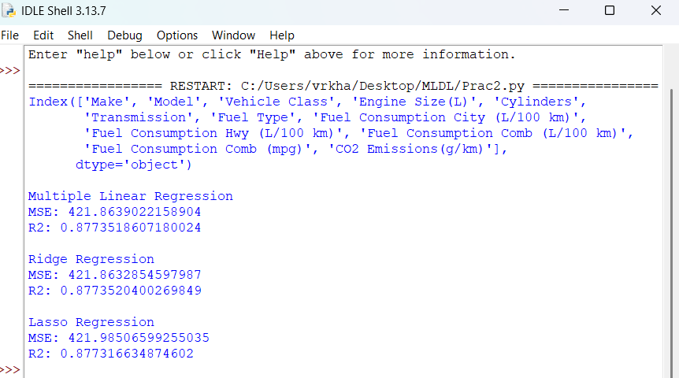
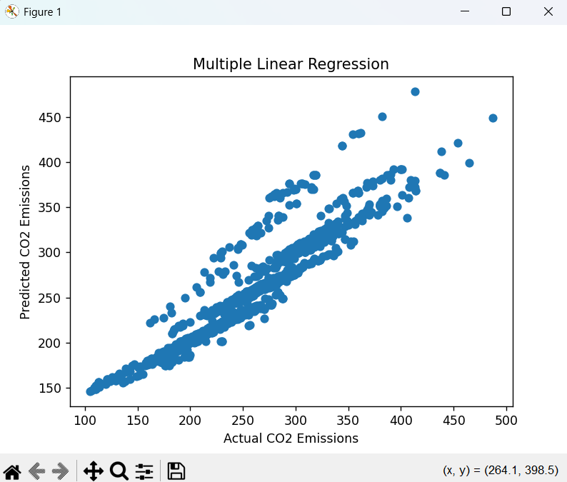
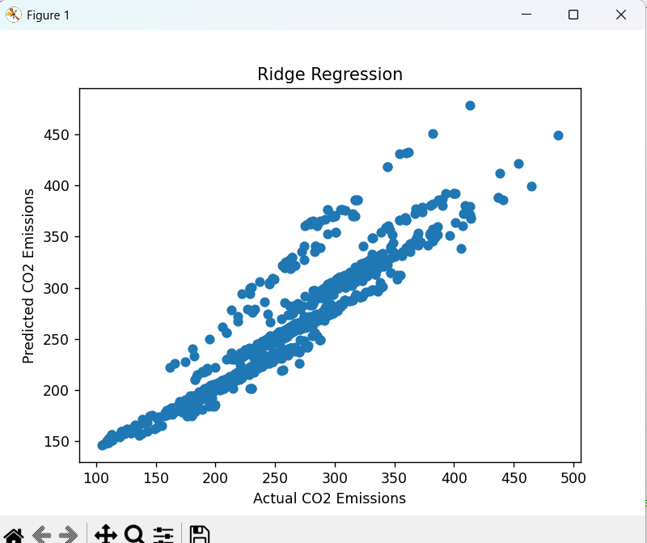
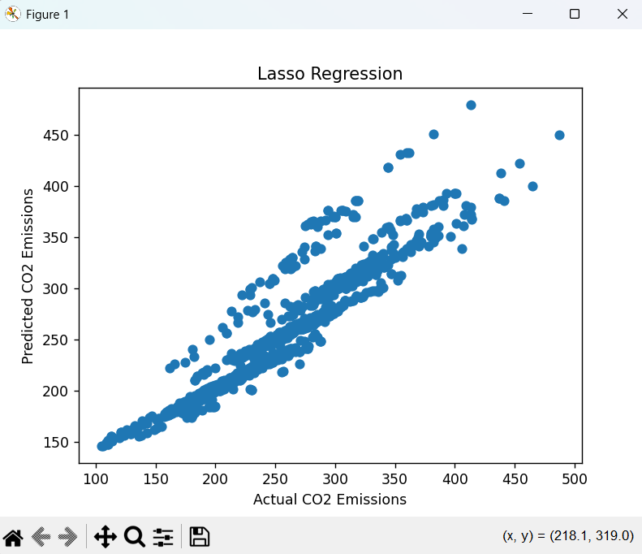
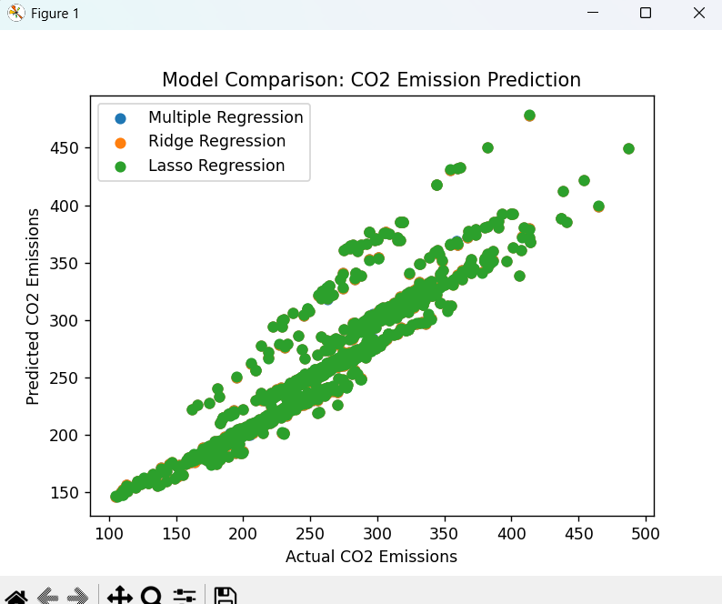
Conclusion
This experiment successfully demonstrated the implementation and comparison of Multiple Linear Regression, Ridge Regression, and Lasso Regression on a real-world dataset. Regularization techniques were shown to improve model robustness and performance when dealing with multiple correlated features.

